**Documentation**

Cypher

17 june 2022

# ***1*** **Team members**

Listing of the individual team members

1. Sheikh Muhammad Adib Bin Sh Abu Bakar
2. Zafirul Izzat Bin Mohamad Zaidi
3. Muhammad Farid Izwan Bin Mohamad Shabri
4. Muhammad Iqbal Bin Mohd Fauzi

# **2** **Introduction**

For our project we plan to make a smart gate controller that is mainly used for controlling people entering a restricted area. For instance, entering a theme park. Our smart gate controller is capable of counting people who are entering and leaving an area through the gate and blocking people from entering the restricted area. To make it more compatible with the big area environment, this system supports controlling and monitoring the gate from distance. This is where we use the concept of the Internet of Things(IoT) where all the components in our system are capable of connecting to the Internet so that the admin can control the gate even though he or she is not there. Since an area could have many gates, we will group all the sensors and actuators for a gate and connect them to a node. This is where we apply the wireless sensors network concept to connect all the nodes with a master controller.

# **3** **Concept description**

The smart gate controller allows the administration of a restricted area like a theme park, zoo or stadium to control the entrance of the area by closing and opening the gate from distance and get the information about the new coming visitor such as the high and the temperature of the visitor, total number of visitor and a current number of visitor. This smart gate controller could also notify the admin if there is a fire near the gate, this feature is to avoid any visitor from entering the area when there is a fire.

To realise that the admin can access the system from distance, wireless network communication is implemented, where all the sensors and actuators are connected to only one node and the node can communicate with the admin known as a client through a server. Those connections use the MQTT protocol. This means that the wifi protocol is also implemented.

The concept of the smart gate controller is visualised in the form of a requirements diagram and overall system architecture as shown in Figure 1 and 2. Table 1 is also included to make clear about the devices, components and application that we use throughout this project.

*  
Figure 1 : Requirement diagram*

The devices, components and actuators used in the system are listed below.

| Type | Name | Function |
| --- | --- | --- |
| Devices | Arduino UNO wifi | As node |
| Raspberry pi | As Server / Broker |
| Mobile phone | As a client |
| Computer |
| Components (Sensors/Actuators) | Fire sensor | Detect fire |
| Distance sensor | Detect distance |
| Temperature sensor | Detect temperature |
| led | Detect fire, lock state, wifi and MQTT connection indicator |
| Step motor | Gate locker |
| Apps | MQTT explorer | On Windows |
| MQTT Clients | On Android and IOS |

Tabe 1: The devices, components and apps used in the system

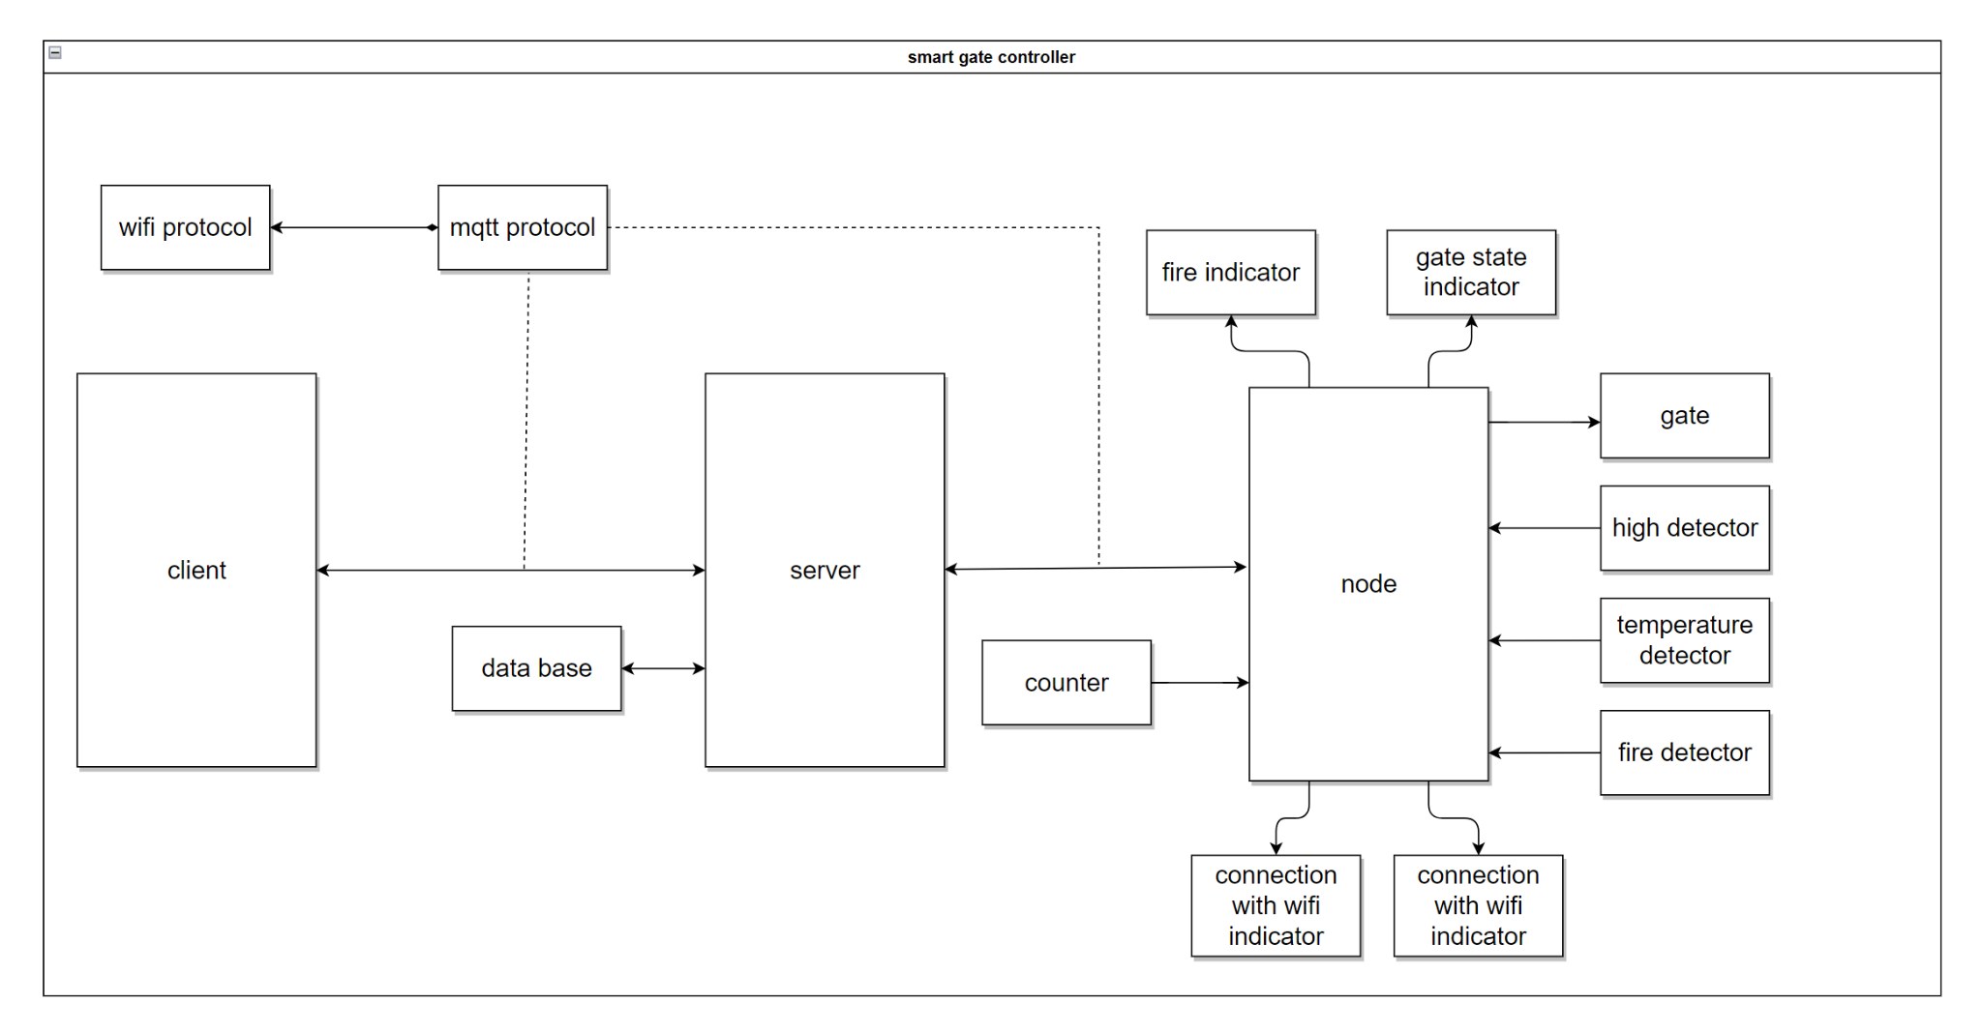Figure 2: Smart gate overview architecture

# **4** **Project/Team management**

For project management, we use the scrum method where we divide the time that we have to develop this product into 11 cycles and each cycle takes 1 week. To make it more efficient, we have two minimum meetings in each cycle. In the first meeting, we will discuss and brainstorm together the big task that we need to complete in the cycle. As a result, the sub-tasks are created and distributed fairly among the team members. The second meeting is to verify the current progress and make improvements.

Since we use the scrum method, we still help each other in completing each sub-task to ensure the product of each cycle is at its highest and finest quality. The division of the tasks is shown in table 2.

| cycle | Task | Subtask | Actor |
| --- | --- | --- | --- |
| 1 | Idea and discussion | Concept | All members |
| 2 | Concept model | Use case | Zafirul Izzat  Farid Izwan |
| Activity |
| Requirement |
| Sequence |
| System architecture | Sheikh Adib  Muhammad Iqbal |
| Draft system architecture |
| Class |
| 3 | Verifying model | All models | All members |
| 4 | Improvement and synchronisation | All models | All members |
| 5 | Discuss for devices, sensors and actuators | Listing all devices, sensors and actuators | All members |
| 6 | Component test | Class for gate + test | Farid Izwan  Muhammad Iqbal |
| Class for temperature + test |
| Class for fire alarm detector + test |
| Class for counter + test | Zafirul Izzat  Sheikh Adib |
| Class for height+ test |
| 7 | Source file | Wifi | Sheikh Adib |
| Mqtt |
| System behaviour | Zafirul Izzat  Farid Izwan |
| API |
| 8 | Server preparation | Prepare platform for installation of raspberry pi | All members |
| Install mosquito |
| Test mosquito with arduino |
| 9 | Integration management | Software management | Zafirul Izzat  Muhammad Iqbal |
|
| Hardware management | Sheikh Adib  Farid Izwan |
|
| 10 | Simulation for a chosen scenario | Test publish topic | All members |
| Test subscribe topic |
| 11 | Documentation | Concept description | Farid Izwan |
| Introduction | Sheikh Adib |
| Project/Team management |
| Technologies | Muhammad Iqbal |
| Implementation | Zafirul Izzat |
| Use case |

Table 2 : Tasks divi*sion*

# **5** **Technologies**

In our smart gate controller, many sensors and actuators are used to simulate our system. The list of the sensors and actuators, their functions and the reasons why we choose them are shown in Table 3.

| Sensors / Actuators | Functions | Reasons |
| --- | --- | --- |
| Flame Sensor (KY-026) | To detect if any fire occurs | Wavelength between 760 - 1100nm (most sensitive) |
| Temperature Sensor (KY-013) | To measure the temperature of visitor | Can measure temperature in the range of -55 °C up to +125 °C |
| lower resistance on higher temperature. |
| Ultrasonic Sensor Module  (KY-050) | To measure the height of visitors | Can measure height in the range of 2 cm to 300cm which is the range of human height. |
| Rotary encoder  (KY-040) | To count the number of visitors | Act as an indicator of either visitor entering (clockwise rotation) or visitor leaving (anticlockwise rotation) |
| RGB 5mm LED Module  (KY-016) | Green = unlock | Act as an indicator to show whether the gate is locked or unlocked. |
| Red = lock |
| 28BYJ-48 DC 5V 12V Stepper Motor | To control the gate either open or close | can be positioned accurately, one 'step' at a time. |
| LED (blue and yellow) | To indicate whether there is fire (blue LED) | There is no display connected to the node, so we use led as the indicators |
| To indicate whether the connection with the server is established or not.( yellow LED) |
| To indicate whether the connection with the server is established or not. ( yellow LED) |

Table 3: Sensors and actuators

In our system, the main communication protocol that is used for the communication between the components in our system is the MQTT protocol. In this protocol, the client, the admin and the node will send a message to the server as a command. If a client subscribes to a specific topic, for example, they will always receive messages from the server. The server acts as a broker in this protocol. According to table 4, there are six topics in our project that can be subscribed by the clients, such as topic gate, topic new visitor, and so on. As a result of its client subscription capability, the system can be more reliable and efficient in certain circumstances.

More than one client, for instance, node and admin, will subscribe to the topics, by using web-based applications, phone apps and desktop apps. For example, we are using the “easymqtt” app, which can be found in the Apple Store or Google Play stores and the “ MQTT-explorer” app on Windows. In order to use the MQTT protocol, the wifi protocol will be used to transmit data between the server and the client.

In developing the software part, we use C++ with Arduino API on Arduino UNO WIFI as the platform for the node. By installing Mosquito software, Raspberry PI acts as a server or a broker for our system.

# **6** **Implementation**

The project implementation consists of designing the static structure of the system and its environment. This design entails many diagrams in order to make it more clear for implementing the system prototype.

First, the reader will be exposed to a class diagram. Then, to know the system and the environment in more detail, use case models will assist the reader. To make it more concrete, the activity diagram is explained based on the use case model. Last but not least, with the help of the previous diagram, we generalise our system into the system architecture.

In this class diagram, we have included both system components and environments. As shown in Figure 3, we can see that the smart gate controller is the centre between all devices in the system and also the environment. The smart gate controller contains features like people count, getting the temperature and measuring the height of the visitor. Since our smart gate controller gets input from both environment and system, then the information is passed through to the controller to take further actions, we can generalise the interactions and come up with the overall system architecture.

Other than the smart gate controller, we have also defined all the entities of each component. As can be seen in the diagram, there are a class of gate, counter, flame detector, temperature detector and height detector. To make the connection work very well on the Arduino Wifi Rev2 board, each smart device and also the application has the same attribute which is the pin number. In gate, it consists of two functions. The first one is the lock that will lock the gate if the admin or the user sends an appropriate command. Then, it also has an unlock function to unlock the gate. Next, the counter. The functions get the number of visitors and update the number of visitors is to know the total of visitors visited in the whole day and the other one is to know the exact number of visitors in that place at a time. Furthermore, a flame detector is also included. The function of the flame is to detect fire. So, if there is fire, then the blue led will turn on to indicate there is fire. Now, we move on to the temperature detector. In this component, the function is to get the temperature of the coming visitor. Whenever a visitor enters the gate, it will give the temperature of the visitor. So, when the client subscribes to a topic called get temperature, the client will obtain the data of the visitor’s temperature. Then, for the height detector, we have to get height as a function. As a piece of additional information, in one of the scenarios, the visitor's height is taken when the visitor enters the gate. Last but not least, we also included other environments such as visitors, sensors, fire and clients as shown in Figure 3.

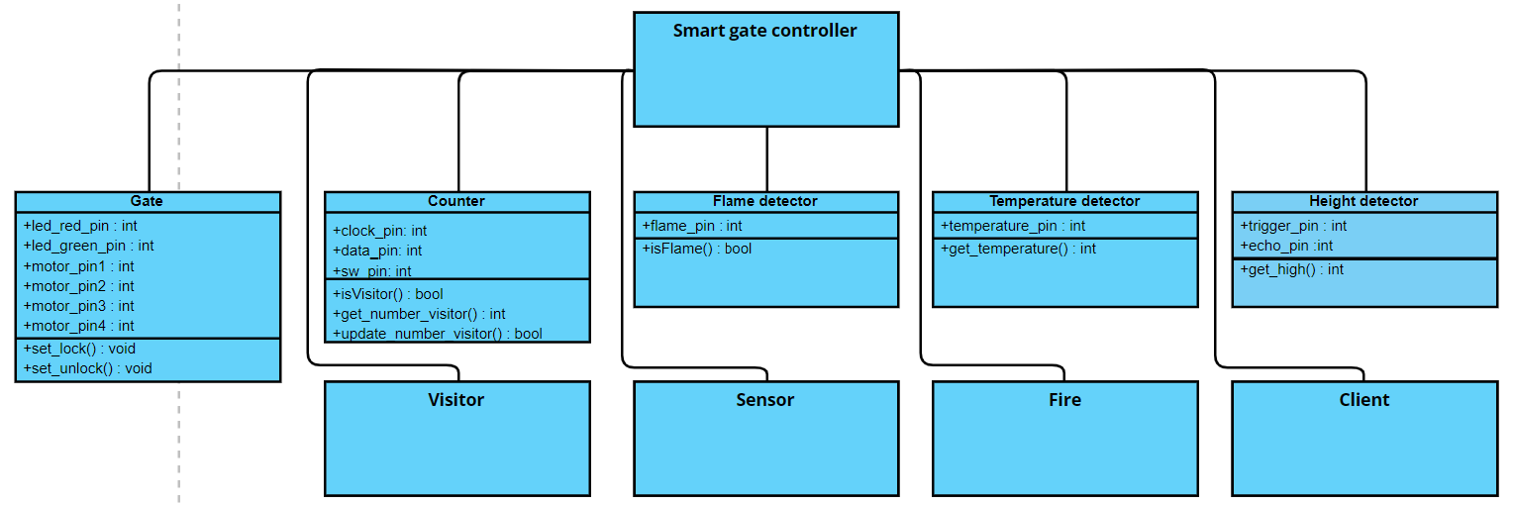

Figure 3: Class diagram

*Our next step is to define the intended behaviour of our system using use cases. We chose this modelling as one of our next methods since it allows us to create a system from th*e standpoint of the user reader. Now, in Figure 4, we describe our use case diagram. With both of the information that we gathered from the diagrams, we have a clearer vision and better understanding of the overall smart gate controller system. This is important as we can now develop a more concrete system architecture with refined details. That is exactly what we did in this documentation for the reader to easily digest our overall system architecture.

As we can see, the outside of the system consists of the user, a node which acts as a middle man in the system and server. The user or also known as the admin can have information on the number of visitors. The user is also capable of sending requests to the server. The main thing about the user is that the user can control the gate remotely. So, the gate can be opened and closed based on the command given by the user. From the node perspective, the node can count visitors entering and leaving with the help of sensors. The node can also get the gate state which is either lock or unlock. Lastly, we move to the server. The server, which is the Raspberry PI, can store the data both from the user and node. Not to forget, the most important part is the data of the system itself. After getting a little bit of knowledge about the overview of our system, we will move to our next approach which is the activity diagram.

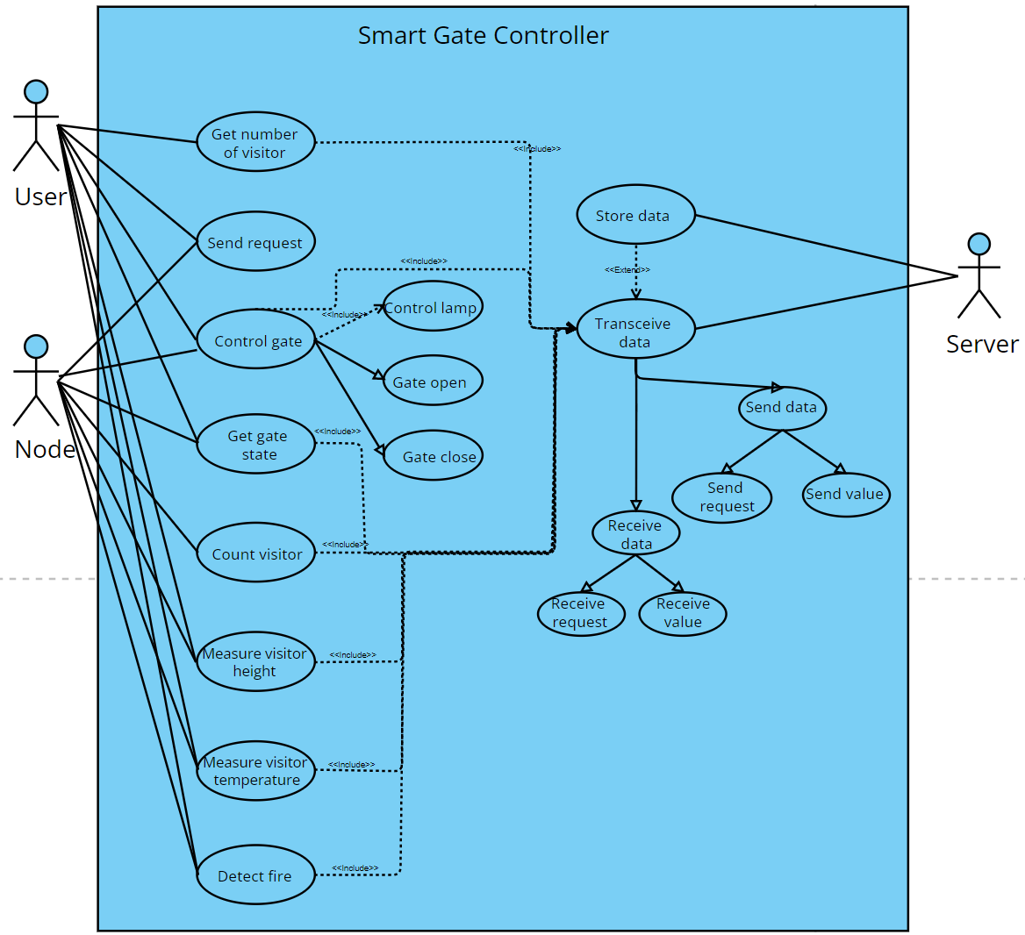Figure 4: Use case diagram

To see more details about the scenario, the activity diagram is modelled. Figure 5 shows how the overall scenario for Smart Gate Controller will be run. Firstly, it will connect to the server. After connecting to the server, it will send data, either the gate will open or close. If the gate is closed, then a green LED will turn on. On the other hand, if the gate is opened, a red LED will pop out.

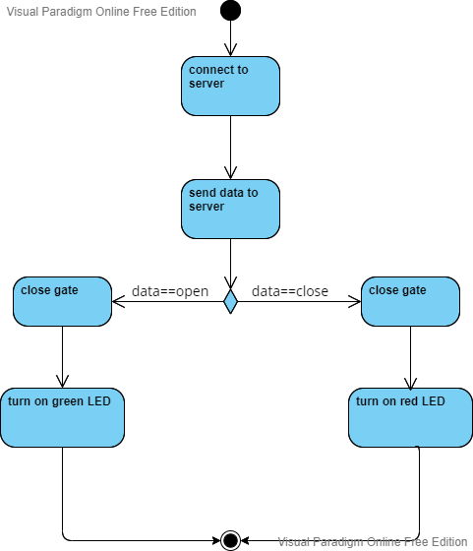

Figure 5: Activity diagram client (node)

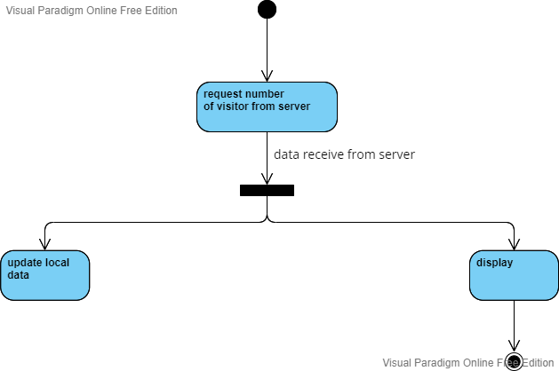

Figure 6: Activity diagram client (admin)

Then, we move to the next Activity diagram. Figure 6 explains how users get the data about the number of visitors. The user will request a number of visitors from the server. Then, the data will be displayed and also local data will be updated once the data is received.

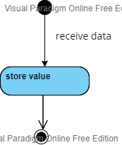

Figure 7: Activity diagram server/broker

Figure 7 shows how data is stored. In the beginning, it will receive data, and then the received data will be stored.

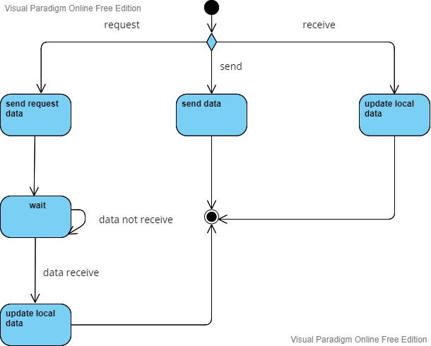

Figure 8: Activity diagram on how the data is transmitted

The diagram in Figure 8, describes how the data is transmitted. From the initial node, there is a decision node on whether the data is requested, received or sent. If the data is requested, then, the required data will be sent. Then, go to wait for the state, if the data is not received. If requested data is received, local data will be updated. Besides that, from the decision node, sending data and updating local data are parts of how data is transmitted.

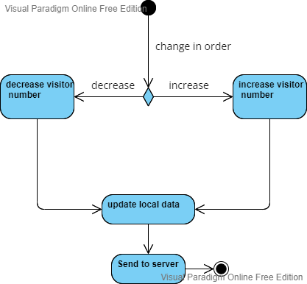

Figure 9: Activity diagram on how the visitor counter works

In Figure 9, explains how the visitor counter works. If there is a change in the number of visitors, if it is either increasing or decreasing, the counter will count the latest number of visitors. Once the latest number is calculated, the local data will be updated and will be sent to the server.

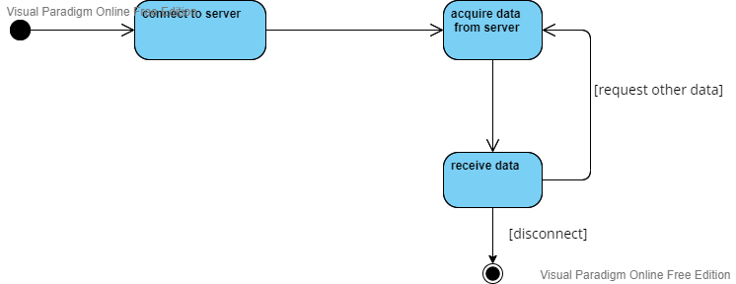

Figure 10: Activity diagram on how the server will receive data

Figure 10 shows how the server will receive data. Initially, the server is connected. The server will request the data. The requested data then will be received by the server. Once the server is done receiving data, it will be disconnected.

With the help of the previous models, we can now form our system architecture. Based on Figure 11 explains the system architecture of the smart gate controller. It consists of Client, Server and Node. For each subsystem, it will define more details, about what happens in every subsystem.

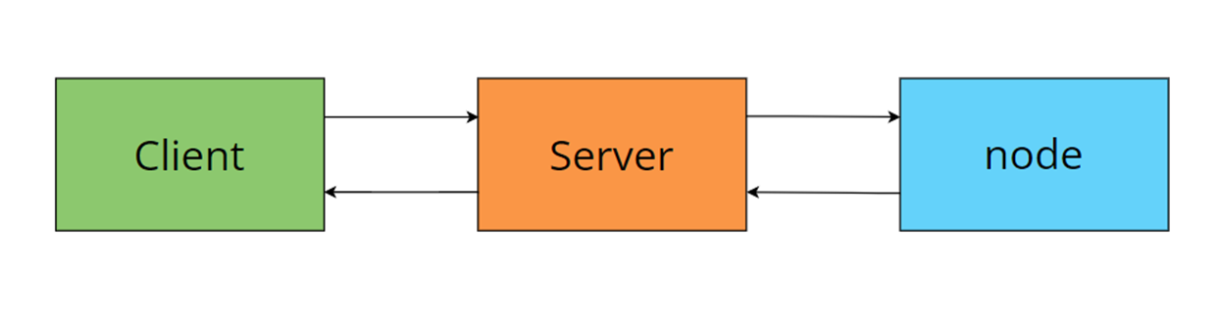

Figure 11: System architecture

Figure 12 shows what the architecture of the client looks like. The client subsystem consists of 5 main components: input interface, output interface, controller, database and communication system.

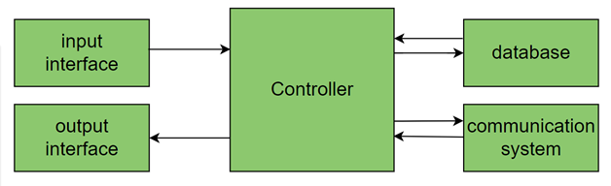

Figure 12: Subsystem architecture of client

For the server subsystem, there are 3 main components that play a big role to make sure the server is good. The three components are the communication system, data manager and database as shown in Figure 13.

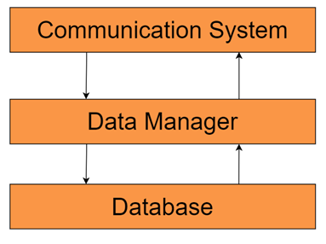

Figure 13: Subsystem architecture of server

Lastly, Figure 14 shows the node subsystem. Node subsystems are made up of 5 main components: communication system, data manager, sensor, actuator and database.

For our project, we will use a rotary sensor to count the number of people. The DC motor is used to open and close the gate. Last but not least is LED which acts as an indicator for visitors to enter and leave.

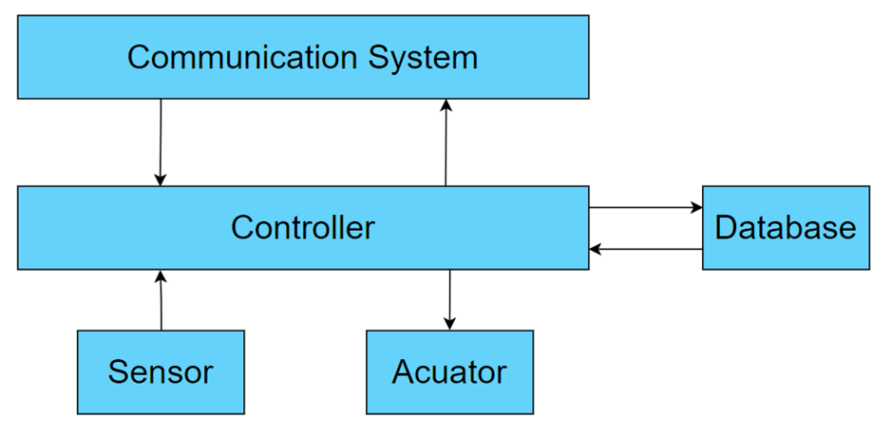

Figure 14: Subsystem architecture of node

# **7** **Use Case**

The instructions on how to use and set up the system are described here. This will assist the reader to simulate the smart gate controller system. As additional information, the reader can refer to Figure 15 in order to have a grasp of overview on how the hardware setup of our system.

1. **Set up manual**

**1. Power up the server**

First we turn on the server.

**2. Power up the node**

After the server is fully on, we must turn on the node. This action will enable the node to connect to the broker which is the server. The wifi indicator will be light on if the node is successfully connected to the wifi and the server indicator will be light on if the node is successfully connected to the server.

**3. Connect the client to the server**

To connect to the server, first, we must install an MQTT application on the phone as an example. In our case, we use easy MQTT as our application to publish and subscribe.

The set-up manual is visualised in Figure 15.

1. **Simulation manual**

**1. How to publish**

The user has to publish the topic that we made as listed in table 4. To help the reader, we also include a picture of how to publish in Figure 16.

**2. How to subscribe**

The user has to subscribe to the topic that we made as listed in table 4. The result of publication and subscription are visualised in Figure 16.

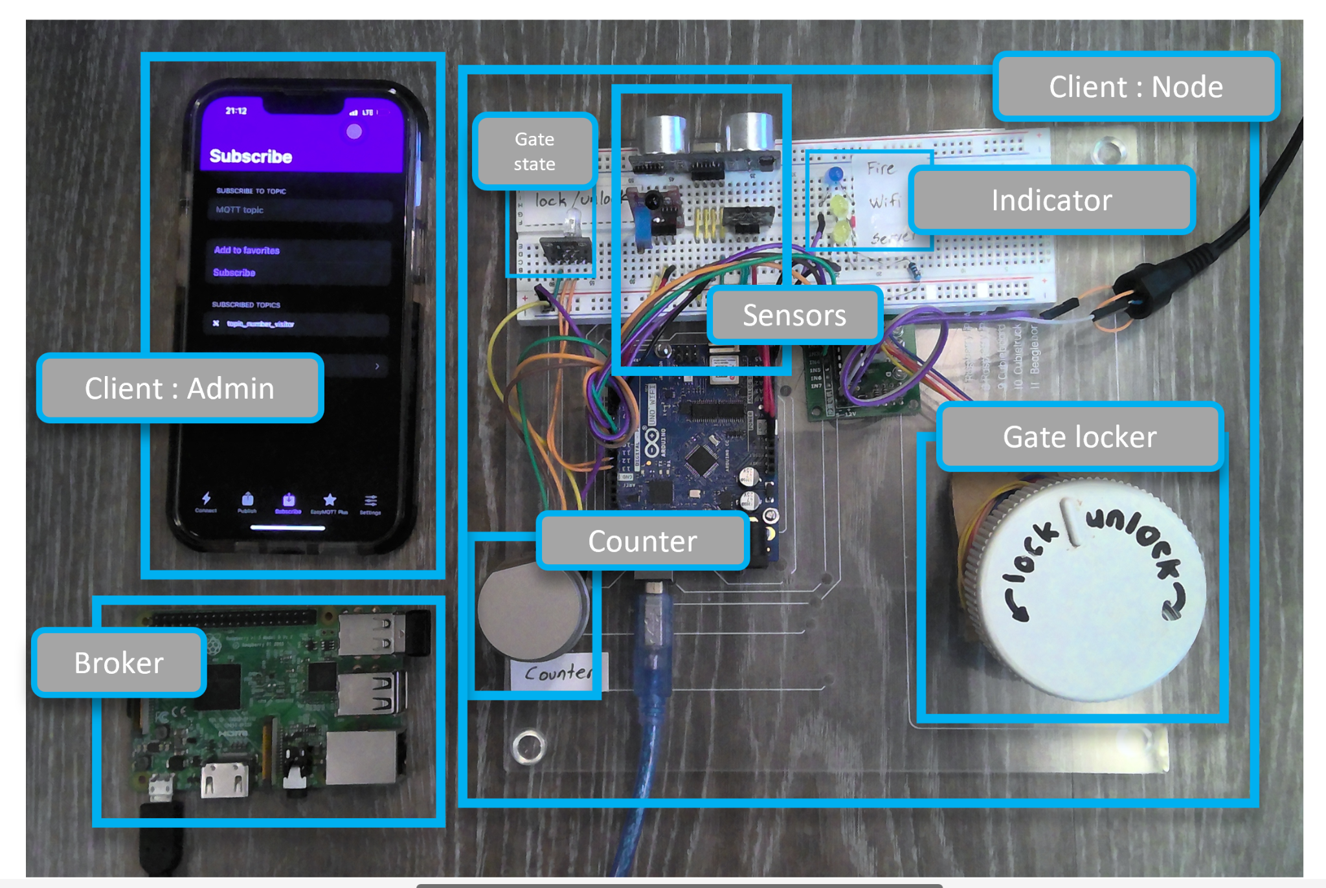

Figure 15: Hardware system setup

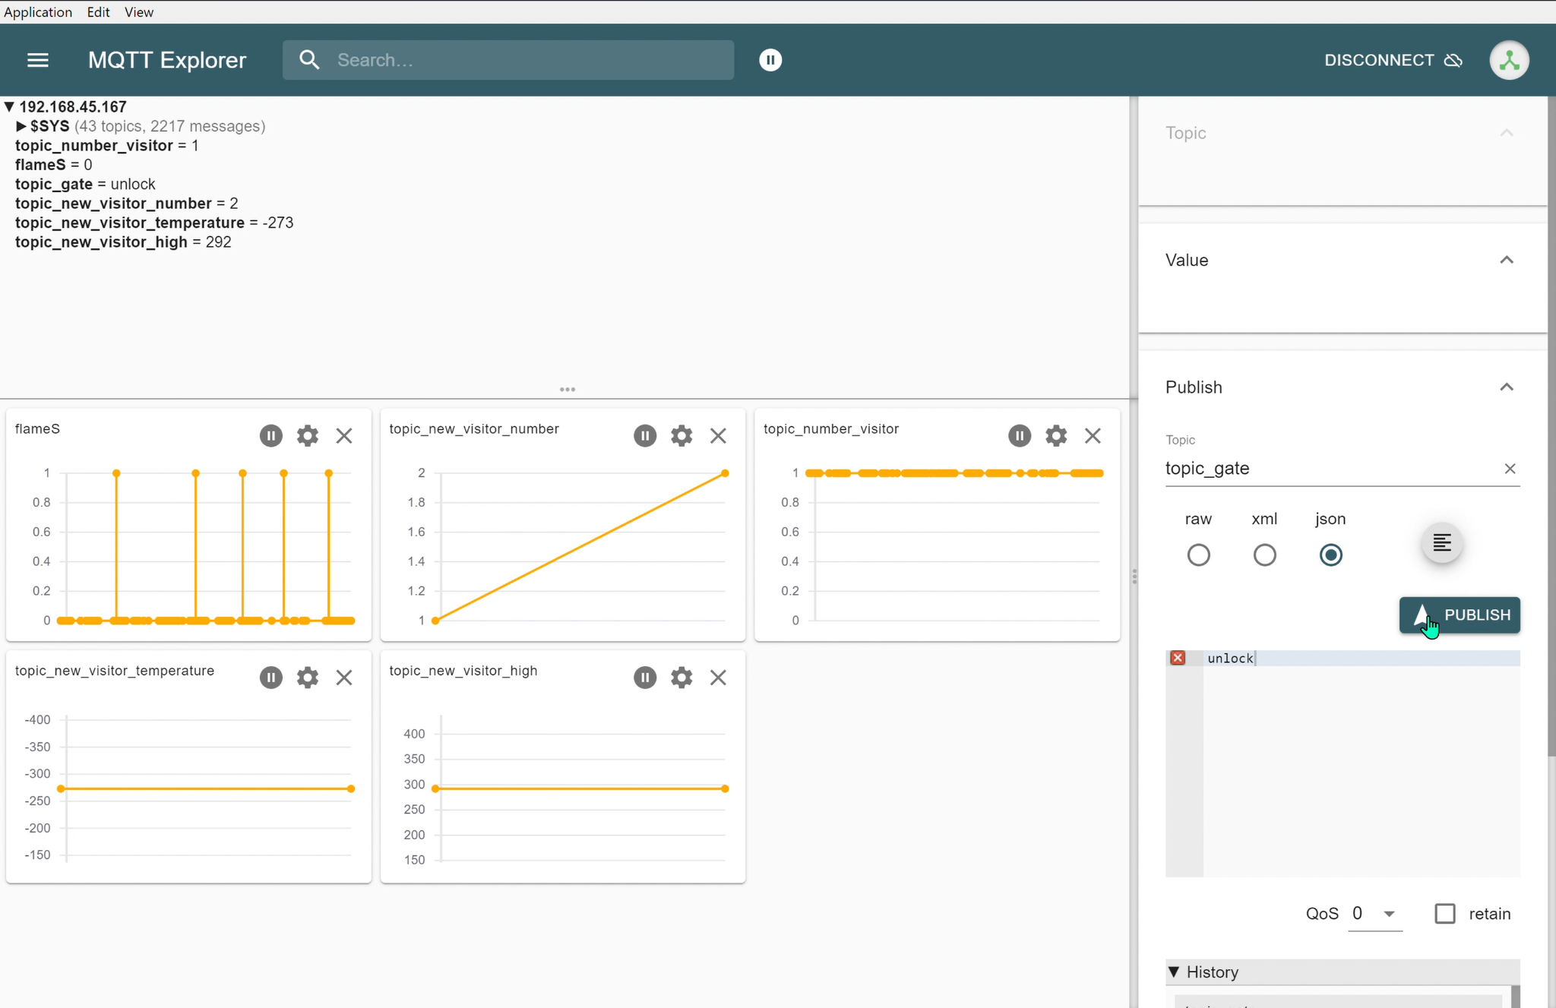

Figure 16: Publish and subscribe using MQTT application

1. **Application environment**

Now we can state that our system has been effectively implemented from a little notion to a robust Smart gate controller. The major reason we picked this project is that we want to show the world that our system can be implemented at any place as long as the requirements are met. There are a few examples of where our Smart gate controller can be implemented.

All of our smart gate controller's features are applicable in theme parks. It is common for a theme park to have a lot of things that must be monitored. For example, the visitor's height must be monitored. It is because some of the rides have a minimum height requirement to use them. Regarding the topic of temperature, it is critical to determine whether the visitor is in good health or not in order to avoid affecting others. Furthermore, due to the current situation with the Covid-19 virus, the temperature of the visitors is required to avoid the spread of Covid-19. When discussing the stadium, not all features will be utilised. It is because the stadium does not require the visitors' height. Only the temperature, visitor count, and other topics are required. The same is true for the zoo, shopping mall, and cinema. The topic height is not required, but the other topics are required so that the admin can monitor the temperature, number of visitors, and total number of visitors.

| Topic | Command | Action | Return value | Remarks |
| --- | --- | --- | --- | --- |
| topic_gate | lock | gate lock, red led on | lock | Admin has the authority to lock and unlock the gate |
| unlock | gate unlock, green led on | unlock |
| topic_new_visitor_high | - | - | New visitor height | Only when a new visitor enters |
| topic_new _vistor_temperature | - | - | New visitor temperature | Only when a new visitor enters |
| topic_number_visitor | - | - | Current number visitor | Total number visitor at that time |
| flame_s | - | Fire indicator light on | Return fire state | Led blue turn on when fire |
| topic_new_visitor_number | - | - | Total number visitor | Total number for the whole day |

Table 4: Topics

# **8** **Sources/References**

1. [embedded-hardware-lab/Projects-Cypher (github.com)](https://github.com/embedded-hardware-lab/Projects-Cypher)
2. MQTT library = [arduino-libraries/ArduinoMqttClient: ArduinoMqttClient Library for Arduino (github.com)](https://github.com/arduino-libraries/ArduinoMqttClient)
3. Wifi library = [WiFiNINA - Arduino Reference](https://www.arduino.cc/reference/en/libraries/wifinina/)